This document is classified as WHITE.
Information is for public, unrestricted dissemination and publication.

initial assessment report

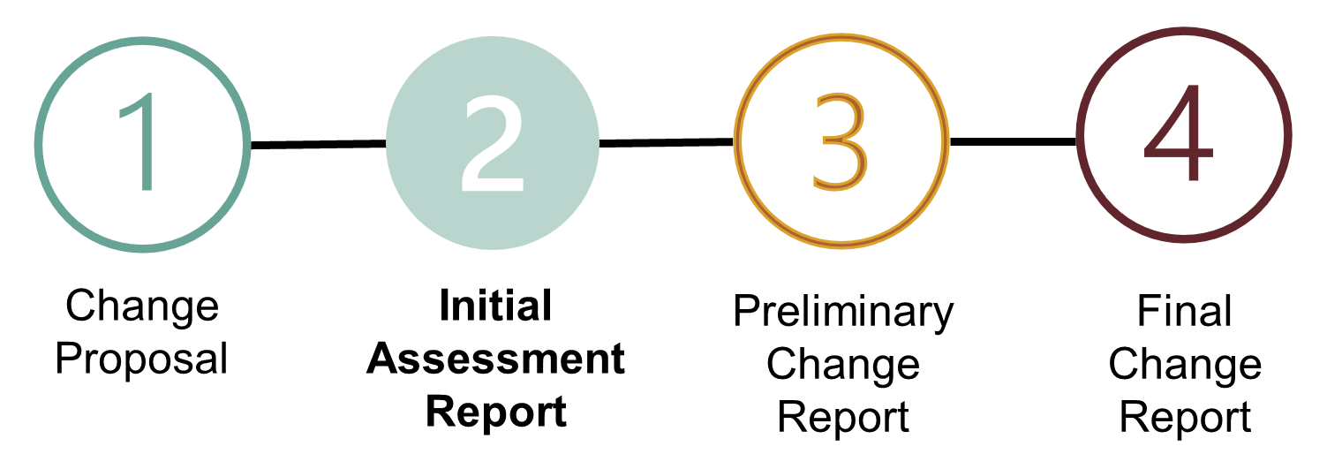

pURPOSE: | This is a written report from the Code Manager setting out their initial assessment of the Change Proposal and planned next steps for progressing the proposal.
Notes: | The Initial Assessment Report is accompanied by a Change Proposal Plan, which describes the Code Manager’s plan for progressing this Change Proposal.  The solution will not be finalised until the publication of the Preliminary Change Report.
Next Steps: | The Change Proposal Plan will set out the next steps for progressing this Change Proposal.  The Code Manager will either propose additional activities to develop and/or assess the solution, or immediately prepare and publish the Preliminary Change Report.

03
Final Change Report
02
Preliminary Change Report
01
Initial Assessment Report
initial assessment report

Rxxxx – Change Title

DOCUMENT VERSION | X.X
DATE ISSUED | DD/MM/YYYY
DOCUMENT APPROVAL STATUS | [APPROVED BY REC CHANGE PANEL/  NOT YET APPROVED BY REC CHANGE PANEL]

RESPONSIBLE COMMITTEE

change overview
[A short executive summary of the change (1-2 sentences)]
High Impact:
[Parties would be detailed here]
Medium Impact:
[Parties would be detailed here]
Low Impact:
[Parties would be detailed here]

1.  2.  3.  4.  5.  6.  7.  8. | summary  problem statement  USER STORIES  IMPACTS  CHANGE PATH AND RESPONSIBLE COMMITTEE  PRIORITY STATUS AND URGENCY  SUMMARY OF CHANGE PROPOSAL PLAN  GLOSSARY | 4  4  4  5  5  6  6  7

Contents
LEAD ANALYST
NAME
EMAIL

technical lead
NAME
EMAIL

assurance lead
NAME
EMAIL

- Summary
[Please provide a summary of the change proposed – i.e. what is the identified issue/change in the existing code that needs to be rectified, how this was identified and why this change needs to be made. Provide details of any activity or analysis that has already been completed]

- problem statement
[The problem statement should address what the problem is; who is experiencing the problem; where and when the problem occurs and why the problem is occurring.]

- user stories
Ref. | user stories
CONSUMER user stories
C1 | [As <a type of Consumer>, I want <goal>, so that <reason>]
C2
C3
C4
MARKET PARTICIPANT user stories
M1 | [As <a Market Participant>, I want <goal>, so that <reason>]
M2
M3
M4

- IMPACTS
REC PARTIES AND SERVICE USERS
REC SERVICE PROVIDERS
CONSUMERS

REC DOCUMENTS / PRODucTS

RECCO AND REC CODE MANAGER

[Add in any additional commentary to support the impacts captured and explain any unexpected gaps]

  - Cross Code Impacts
[Provide the main impacts so that readers have an overview of how the change proposed will affect the other industry codes.]

- CHANGE PATH AND RESpONSIBLE COMMITTEE
CHANGE PATH | SELF-GOVERNANCE / AUTHORITY DETERMINED
RESPONSIBLE COMMITTEE

[Provide an explanation of how the Change Path and Responsible Committee have been defined.
Where a change is Authority Determined, provide the justification based on the Criteria set out in the Change Management Schedule.
Provide explanation for the Responsible Committee, based on the document(s) impacted and any justification for ‘upgrading’ or ‘downgrading’ the Committee based on relevance/suitability]

- PRIORITY status AND URGENCY
PRIORITY status | LOW / MEDIUM / HIGH / CRITICAL
URGENCY | STANDARD / URGENT

[Provide any detail that supports/explains the defined Priority Status – e.g. output from the Prioritisation Matrix.
If a Change is deemed to be Urgent, confirm the reason/justification, examples:
- The change needs to be linked to a specific date (e.g. introduction of legislation, system release date, planned consultation or impact assessment timings, etc.);
- Change is needed quickly to stop an identified issue from escalating significantly, and the detrimental impact would continue/worsen if no change is made; or
- There are other changes / activities dependent on the progression of the change that need to be completed in a given timescale.]

- SUMMARY OF CHANGE PROPOSAL PLAN
[Explanation of the elements included and excluded from the plan and the justification, with focus on exceptions to a ‘standard’ change plan approach e.g. where SME support is required, where a change will move to PCR without the need for solution development activity]
 | FROM | TO
Service Provider Impact Assessment issued | DD/MM/YYYY | DD/MM/YYYY
Party Impact Assessment issued
deadline for alternative change proposal submission
Preliminary Change Report issued
Consultation issued
Final Change Report issued
responsible committee decision
Authority determination
Appeal window closure

- GLOSSARY
TERM | DEFINITION
[Term] | [Formal definition, taken from REC schedules or other appropriate documents]

