This document is classified as WHITE.
Information is for public, unrestricted dissemination and publication.

change proposal form (COPY)

PLEASE NOTE: THIS IS A COPY FOR INFORMATION ONLY. tO SUBMIT A CHANGE PROPOSAL PLEASE USE THE ONLINE FORM ON THE REC PORTAL.

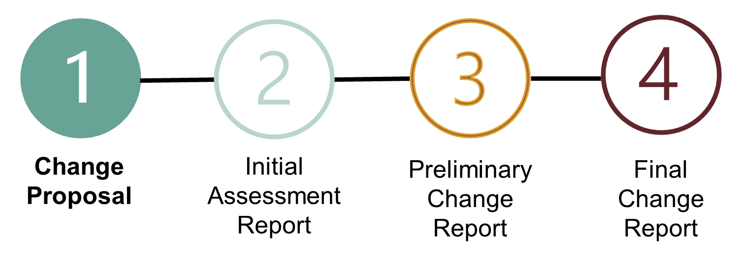

pURPOSE: | This is a copy of the Change Proposal Form submitted by the Proposer on the REC Portal.
Notes: | The information in this form is subjective to the views of the Proposer at the time of submitting the form, and prior to formal assessment by the Code Manager.  The solution will not be finalised until the publication of the Preliminary Change Report.
Next Steps: | The Code Manager will complete an initial assessment of the Change Proposal and determine if additional development or assessments is required.  The Initial Assessment Report will be published with the Change Proposal Plan and reviewed by the Change Panel.

- PERSONAL DETAILS
PROPOSER NAME
(Mandatory)
COMPANY
(Optional)
COMPANY TYPE  (Optional) | Choose an item
TELEPHONE NUMBER
(Optional)
EMAIL ADDRESS
(Mandatory)

- CHANGE PROPOSAL summary
CHANGE PROPOSAL TITLE
(Mandatory)
WHAT IS THE ISSUE YOU ARE SEEKING TO SOLVE?
(Mandatory)
WHAT IMPACT IS THIS HAVING?
(Mandatory)
WHAT OUTCOMES DO YOU CONSIDER ARE NEEDED TO ACHIEVE AN EFFECTIVE SOLUTION?
(Mandatory)
IS THERE ANY BACKGROUND INFORMATION OR CONTEXT TO THE CHANGE PROPOSAL THAT WOULD BE USEFUL?
(Optional)

- Consumer impacts
WHICH CONSUMER TYPES WILL BE IMPACTED BY THIS CHANGE PROPOSAL?  (Mandatory) | ☐ Electricity  ☐ Gas  ☐ Domestic Prepayment  ☐ Domestic Credit  ☐ Microbusiness  ☐ Small and Medium Enterprise (SME)  ☐ Industrial and Commercial (I&C)  ☐ Other (please specify in the Additional information box below)
WHAT IMPACT WILL THIS CHANGE PROPOSAL HAVE FOR THESE CONSUMERS?  (Mandatory) | ☐ Switching experience  ☐ Billing accuracy  ☐ Trust and confidence  ☐ Safety  ☐ Security of supply  ☐ Ability to pay  ☐ On site experience  ☐ Other (please provide details in the Additional information box below)
ADDITIONAL INFORMATION
(Optional)

- code impacts
Does this Issue relate to or impact:
THE REC OR REC SCHEDULES?  (Optional) | ☐ Main Body  ☐ Interpretations and Definitions Schedule  ☐ Transition Schedule  ☐ Accession Agreement  ☐ Company Governance Schedule  ☐ Change Management Schedule  ☐ Performance Assurance Schedule  ☐ Qualification and Maintenance Schedule  ☐ Market Exit Schedule  ☐ Charging Methodology Schedule  ☐ Prepayment Arrangements Schedule  ☐ Central Switching Service Schedule  ☐ Data Access Schedule  ☐ Energy Theft Reduction Schedule  ☐ Transfer of Consumer Data Schedule  ☐ Metering Operations Schedule  ☐ Metering Accreditation Schedule  ☐ Smart Meter Installation Schedule  ☐ Secure Data Exchange Schedule  ☐ Green Deal Arrangements Schedule  ☐ Registration Services Schedule  ☐ Related Metering Points Schedule  ☐ Address Management Schedule  ☐ Switching Data Management Schedule  ☐ RMP Lifecycle Schedule  ☐ Switching Service Management Schedule  ☐ Resolution of Consumer Facing Switching and Billing Issues Schedule  ☐ SPAA Transition Schedule  ☐ MRA Transition Schedule  ☐ Unbilled Energy Code of Practice  ☐ Gas Metering Code of Practice  ☐ MOCoPA  ☐ ASPCoP  ☐ Change Panel Terms of Reference  ☐ Performance Assurance Board Terms of Reference
ADDITIONAL INFORMATION
(Optional)

THE DATA SPECIFICATION?  (Optional) | ☐ Data Item Catalogue  ☐ Market Message Catalogue  ☐ Data Access Matrix  ☐ Standards Definition
ADDITIONAL INFORMATION
(Optional)

CENTRAL SYSTEMS OR REC SERVICES?  (Optional) | ☐ Electricity Enquiry Service  ☐ Central Data Service Provider Further Services  ☐ Secure Data Exchange Service  ☐ Green Deal Central Charging Database  ☐ Central Switching Service (CSS)  ☐ CSS Certificate Authority  ☐ Switching Operator  ☐ Gas Retail Data Service  ☐ Electricity Retail Data Service  ☐ Gas Enquiry Service  ☐ Energy Theft Tip Off Service (ETTOS)
ADDITIONAL INFORMATION
(Optional)

REC PARTIES AND/OR MARKET PARTICIPANTS?  (Optional) | ☐ Energy Suppliers  ☐ Distribution Network Operators  ☐ Gas Transporters  ☐ Metering Equipment Managers  ☐ DCC  ☐ Shippers  ☐ Data Collectors  ☐ Data Aggregators  ☐ Green Deal Providers  ☐ Green Deal Finance Parties  ☐ Meter Asset Providers  ☐ AMR Service Providers  ☐ EES Users  ☐ GES Users  ☐ GDCC Users  ☐ Other (please provide details in the Additional Information box)
ADDITIONAL INFORMATION
(Optional)

OTHER INDUSTRY CODES?  (Optional) | ☐ BSC  ☐ DCUSA  ☐ SEC  ☐ UNC  ☐ IGT UNC
ADDITIONAL INFORMATION
(Optional)

DOES THIS CHANGE PROPOSAL IMPACT A SIGNIFICANT CODE REVIEW?  (Optional) | Choose an item
ADDITIONAL INFORMATION
(Optional)

- change progression
Do you believe this Change Proposal meets the criteria for ‘Urgency’ and should be progressed under an urgent timetable?

If so, please PRovide justification?
(Optional)
Are there any required timescales for the development or implementation of this Change Proposal?
(Optional)
Are you aware of any dependencies associated with the Change Proposal which may impact its priority or progression timetable?
(Optional)
Does this Change Proposal relate to an existing or previous Change Proposal?
(Optional)

- ATTACHMENTS
ATTACH/PROVIDE ANY SUPPORTING DOCUMENTS TO BE SUBMITTED WITH THE FORM

