|  |
| --- |
| Electricity Enquiry Service, CSS User Guide |
|  |
| January 2022  Version 2.2 |



Contents

Contents 2

Document Control 3

EES – Receipt of Central Switching Service (CSS) Synchronisation Messages 4

Accessing EES 5

Searching in EES 5

Returned results 6

Searching for Retail Energy Location addresses within EES 7

MPAN details 9

New CSS data 10

CSS switching summary 10

ERDS sourced data 15

**DISCLAIMER**: Please note for the purposes of this User Guide, we have included real-life screenshots to assist users in navigating the new functional areas of the EES website. Please note we have redacted any personal information related to these screens, but have kept some level of switching information in, to provide a clear instruction to users.

Document Control

|  |  |  |
| --- | --- | --- |
| Version | Date | Reason for Change |
| 2.2 | 17/01/2022 | First version-controlled version.  Addition of CR-D109 solution for Closer Alignment of REL searching in EES and GES – UIT release. |

EES – Receipt of Central Switching Service (CSS) Synchronisation Messages

Following the Implementation of the Central Switching Service (CSS), the Electricity Enquiry Service (EES) will begin to receive near ‘real-time’ Switching Synchronisation messages, which will be exposed to EES users on the EES User Interface (website portal) and API.

The following user guide sets out the expected behaviour of the EES in relation to any testing undertaken during the Consequential Testing phase of the Switching Programme.

Please note: Only the EES User Interface is in scope of this document, for expected behaviours related to the EES API, please see: *EES API Webservice Interface Specification (CSS Programme) v3.1.0*

css messages received by ecoes

The messages received from EES by the CSS are as follows:

|  |  |
| --- | --- |
| Synchronisation Message | Description of Synchronisation Message |
| Registration Pending (RECM_SN_2400) | This synchronisation message is sent as a result of a change in status to “Pending” for an Initial Registration or Switch Request |
| Registration Secured Active (RECM_SN_2460) | This synchronisation message is sent as a result of a change in status to “Secured Active” for an Initial Registration or Switch Request |
| Registration Secured Inactive (RECM_SN_2460) | This synchronisation message is sent as a result of a change in status to “Secured Inactive” for a Switch Request or Deactivation |
| Registration Cancelled (RECM_SN_2460) | This synchronisation message is sent as a result of a change in status to “Cancelled” for a Switch Request or Intervention. |
| Registration Event (RECM_SN_2450) | This synchronisation message is sent as a result of a change to an existing registration (change in Domestic Premise Indicator) |
| Retail Energy Location (RECM_SN_2600) | This synchronisation message is sent as a result of a change to a Retail Energy Location (REL) to an existing registration or upon an Initial Registration being Secured Active. |

Accessing EES

Users will be able to access the test version of the EES User Interface, following the URL: **https://uit.ecoes.co.uk/**

Users will be asked to log in to the EES using their testing-specific username/ password

Fig.1 – EES Log in Screen

Users will need to contact their Master Administration User for the UIT environment if they require a login. If access for a company still needs to be granted, users should submit the request through: <https://switchingprogramme.atlassian.net/servicedesk/>

Searching in EES

The search method within EES has not been adjusted for Front End users.

***Please Note: There has been a change to the way EES is searching for Retail Energy Location address, please refer to a later section of this document: Retail Energy Location***

Fig.2 Searching in EES



Users will be able to use the same parameters to search for sites contained within EES as they do to-date:

* MPAN
* Meter Serial Number
* Partial Address Details (where no postcode is entered the user must enter at least 2 non-numeric fragments)

Once search selection has been inputted the user is able to search using the search icon  or pressing enter.

FIG.3 Advanced Search Parameters

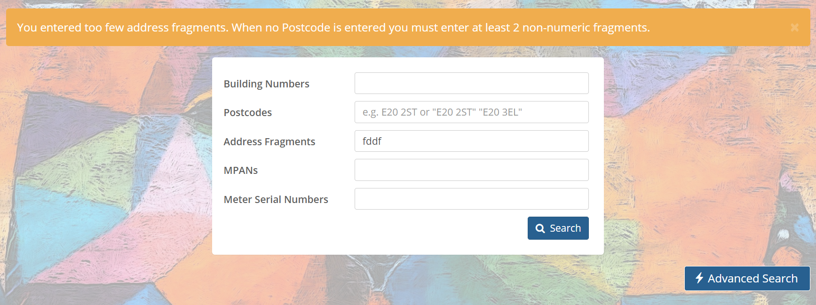

In cases where no match has been found for the search parameters inputted by the user, the above screen will show with the error message ***“You Entered too few address fragments. When no Postcode is entered you must enter at least 2 non-numeric fragments”***

Users will be able to select the  function which will present the above screen to assist users in refining their search parameters.

Returned results

Once the search parameters have been met, EES will return a distinct record or multiple records associated with the search criteria provided.

FIG.4 RESULTS SCREEN (MPAN/ Address information redacted)

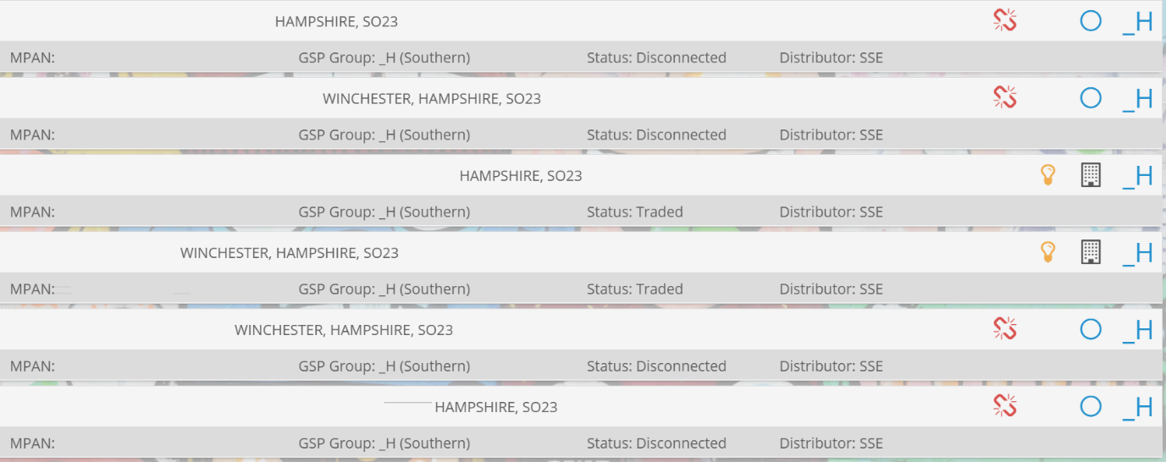

The user has the ability to select a record from the returned list of results. Once a record is selected this will open the full MPAN Details Screen (users will see relevant data for their user permissions).

Searching for Retail Energy Location addresses within EES

This will be a new feature for EES following the implementation of the CSS is the receipt of the Retail Energy Location (REL) addresses.

These REL addresses are stored within EES and are exposed to users through the MPAN Details page, following Data Protection approval that users are looking at this for the purposes of enabling switching (as will be required by the REC). Access to the Retail Energy Location search functionality is determined by the MPIDs and Market Roles associated with the current users Company Group. For example, REL search functionality may only be available to Suppliers and TPIs. For Suppliers to access the functionality, it must belong to a Company Group with an MPID containing the ‘Supplier’ Market Role.

When logging into the website, if the user belongs to a Company Group with access to the Retail Energy Location search functionality, the user will be presented with a Terms of Use window asking them to confirm that they are using the site for the purposes of switching. The user must select ‘Agree and Continue’ to access the site.

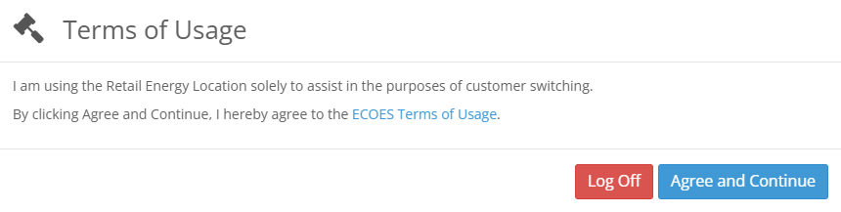

Figure 1: Terms of Usage - including Retail Energy Location agreement

Selecting ‘Agree and Continue’ will enable the REL search functionality for that user. The user can toggle the REL search functionality on and off through the ‘Using For Switching’ control, available in the search setting cog. Setting the ‘Using For Switching’ control to ‘off’ will result in the Primary Search functionality querying MPL data only. The system will remember the users last setting and this will be come the default the next time they access the site. For clarity, the user must not access the REL where this is not for switching purposes.

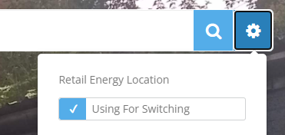

Figure 2: Using For Switching control

When ‘Using For Switching’ is set to ‘on’, the Primary Search function will look at both MPL and REL data when searching by address.

REL data **will not** be searched and returned if an MPAN or MSN is included in the search text.

REL data **will** be searched and returned if the search text consists of postcodes and address fragments only.

If REL data is searched, due to the ‘Using For Switching’ controlling being set to on, and the user entering postcode and address fragments only, the search results will include REL data.



Figure 3: Search result including REL address

If an MPAN has been returned due to a match on a REL address, but no match on the MPL address, this will be highlighted by the green map marker icon.



Figure 4: Map marker icon, highlighting match on REL but on MPL data

If a user wishes to search against REL data, but does not wish for the REL data to be included in their search results, they can toggle the display through the ‘Display REL Addresses’ control within the search settings cog.

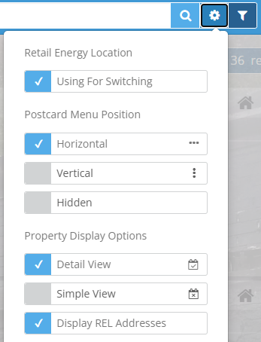

Figure 5: Display REL Addresses control

If the ‘Display REL Addresses’ control is turned off, the REL address information will not be displayed within the users search results.



Figure 6: REL search results with 'Display REL Addresses' turned off

With ‘Display REL Addresses’ turned off, a user can still view the REL address information for an individual search result by clicking the ‘Get REL Address’ button within the search result. Clicking this button will display the REL data for that MPAN only.

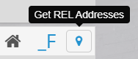

Figure 7: Get REL Address button

MPAN details

The MPAN Details screen will look and feel similar to users who have accessed EES prior to the CSS Go-Live. Upon Go-Live of the new Switching Arrangements, EES will receive real-time switching data from the CSS and will expose this switching data to users within 6 seconds of receipt and successful processing of this message.

EES will also continue to receive ERDS (previously known as the MPAS) updates via a nightly batch process, therefore information mastered by the ERDS systems and provided to the EES via the ERDS will be updated and exposed to users once the batch has been successfully processed.

New CSS data

EES will receive a number of new synchronisation messages from the CSS. The following section sets out how the user can interact with this data and understand the expected behaviour from EES.

CSS switching summary

The CSS Switching Summary parameter of the MPAN details screen will reflect the status of the latest CSS Switching Synchronisation message received by ECOES. The Information will remain available in the CSS Switching Summary section until a new message supersedes it.

Users will find this information at the bottom of the MPAN details screen.

FIG.5 css switching summary screen shot

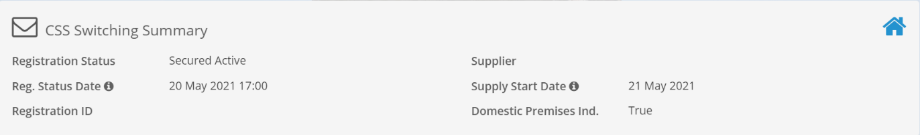

EES will expose the attributes associated to the CSS synchronisation message as confirmed within Fig.5. Users should note:

* The Registration Status Date reflects the time/ date the Registration Status changes
* The Supply Start Date reflects the date on which the supplier has requested to become the supplier of the RMP.
* The Icon  reflects the status of the Domestic Premises Indicator per the last Registration Pending or Registration Event Synchronisation message received for the associated MPAN.
  + Where the Domestic Premise indicator is set to ‘True’ the house icon will hold a blue styling
  + Where the Domestic Premise indicator is set to ‘False’ the house icon will hold a grey styling

css switching messages

The CSS Switching Messages parameter of the MPAN details screen will reflect all CSS synchronisation messages received for the associated MPAN within the last 90 calendar days. Once the 90 day threshold has been reached, the message will no longer be available for view by the user.

Users will find this information at the bottom of the MPAN details screen.

FIG.6 css switching messages screen shot

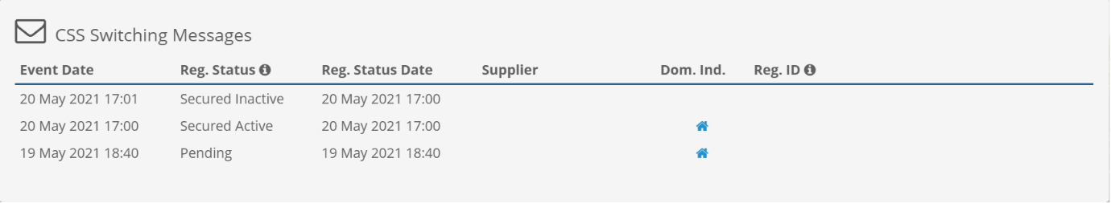

EES will expose the attributes associated to the CSS synchronisation message as confirmed within Fig.6. Users should note:

* Column indicators with a  icon associated confirm that users are able to hover over the information contained within that column to gather further information.

FIG.7 css switching messages information icon

**Registration Status:** User can access the Event Type associated to a message by hovering over the message within the table.

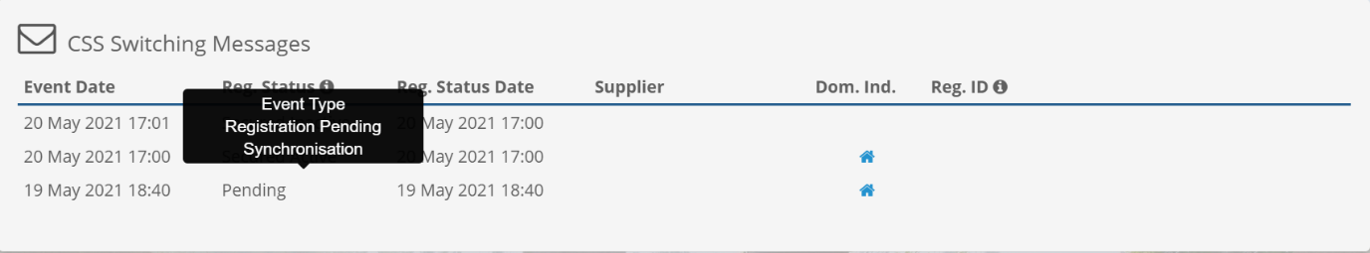

**Registration ID:** User can access the payload information contained within the message by hovering over the message within the table.

*Example 1: Pending Synchronisation Message – Registration ID information – Confirms Supply Start Date confirmed in Payload*

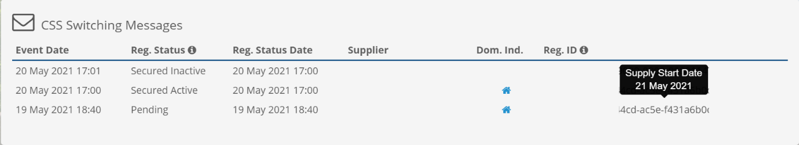

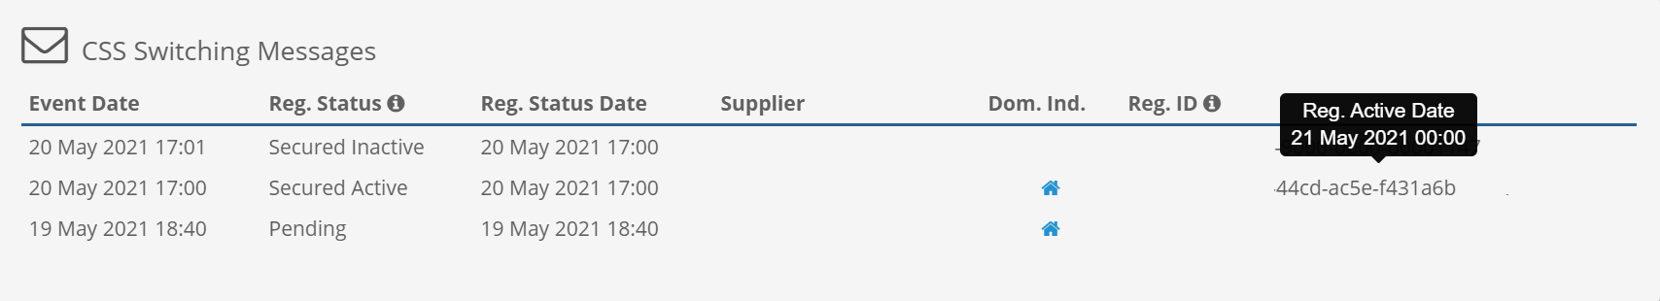*Example 2: Secured Active Synchronisation Message – Registration ID Information – Confirms Registration Active Status Effective Date and Time*

supplier information

EES will receive two sets of supplier information from two different master systems (CSS & ERDS). The CSS will now master the switching information and therefore the CSS Switching messages will confirm which supplier is to take over the registration of the MPAN. Upon the time/date the Supply Start date is due to take effect the Supplier parameter of the ECOES MPAN Details page will be updated. This Supplier information will be consistent with the Supplier MPID and CSS Switching Messages received. In most cases the CSS Switching Summary will also confirm the last CSS Message received is a Secured Active Synchronisation message. per Fig.8.

*Note: ERDS still provides the Supplier & Meter History Parameter of the MPAN Details screen. It is important for users to note that CSS messages are received in near real-time whereas the MPRS batch is updated on a nightly basis. Please see ERDS Data Section of this document for more information on the expected behaviours of the ERDS driven data within ECOES.*

FIG.8 supplier parameter screen shot

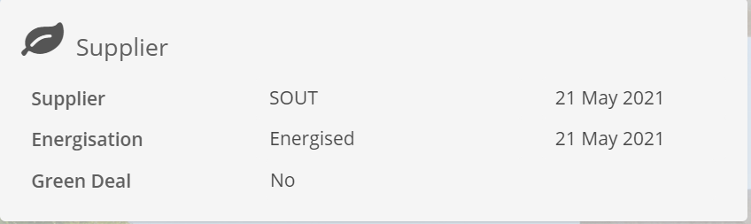

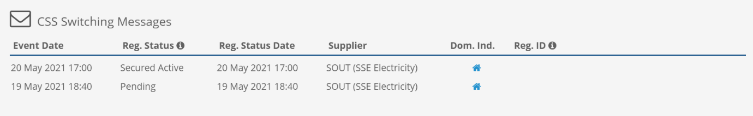

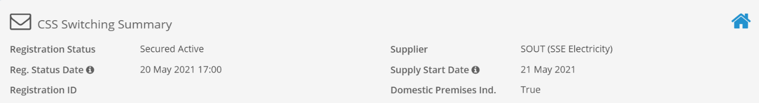

retail energy location

The Retail Energy Location (REL) is accessible to users once within the MPAN Details screen.

Users can access the information through the Address parameter of the MPAN Details screen.

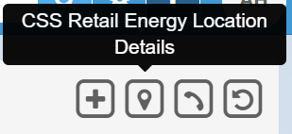FIG.9 accessing retail energy location through mpan details screen

Users with access to REL search functionality will have access to the Retails Energy Location data from the MPAN details page. A user with access will need to select the location icon to view the associated Retail Energy Locations.

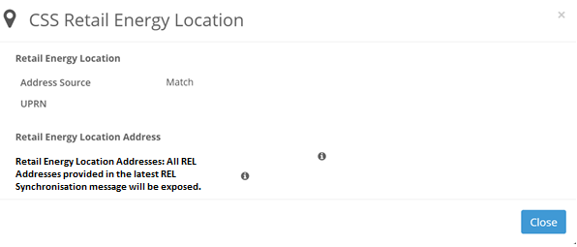

Users should note the following:

* EES will expose only the latest Retail Energy Location addresses and payload as provided within the latest CSS Retail Energy Location Address Synchronisation message. Every instance of a new synchronisation message received by ECOES supersedes the previous message payload exposed.
* The initial CSS Retail Energy Location screen will provide the following information:
  + Address Source
  + UPRN
  + Retail Energy Location Addresses
  + Confidence Score

In order for users to access the details of all the REL Payload information provided in the synchronisation message, users will need to hover over the  to expose the information

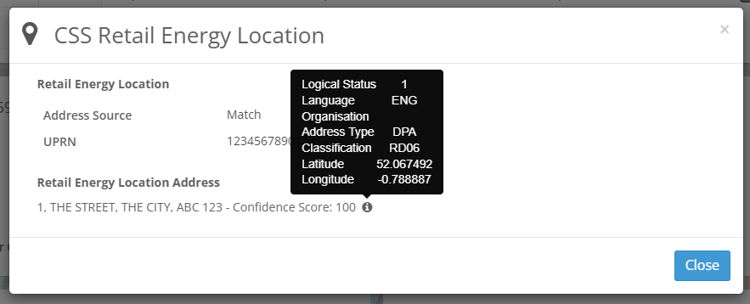

cancelled registrations

Registration Cancellation synchronisation messages will be received from CSS. Users will be able to see the Cancelled message through the CSS Switching Messages and Summary Screens.

FIG.10 cancelled registration css switching messages

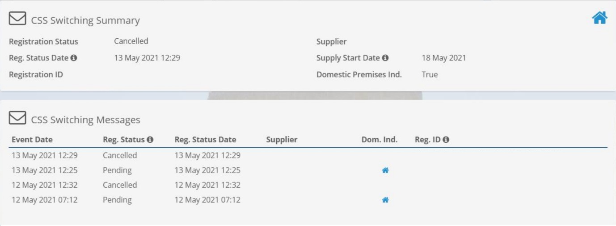

fig.11 cancelled registration “registration notes”

Once the Cancelled Registration Synchronisation Message has been received, as confirmed under Fig.10 the CSS Switching Messages and CSS Switching Summary parameters will expose the Cancelled synchronisation message as soon as ECOES has processed the message successfully.

However, as noted in the **ERDS Sourced Data** section of this document, the Supplier and Meter History parameter of EES will remain mastered and updated when the MPRS batch feed has been completed. Therefore, in cases where a cancelled registration has taken place, the following Registration Notes will be exposed once the batch associated with the MPAN has been processed.

User will expect to see the following view:

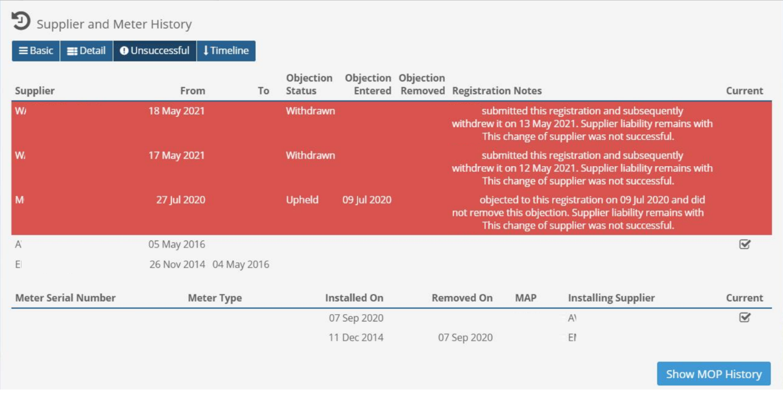

ERDS sourced data

A number of data items will continue to be mastered through ERDS (previously known as MPAS) systems and be loaded through to EES via the ERDS feed on a nightly basis.

The following aspects of the MPAN Details screen will continue to be mastered by ERDS:

* Current Meter Details
* Historic Meter Details
* Historic Supplier and MEM Details
* MPAN Details
* Settlement Parameters
* Smart Communications
* Supplier Agent Details
* MPAN Relationship Data

User’s should note:

* The Details noted above will be updated when the ERDS batch feed is loaded through to EES, during UEPT & E2E Testing, we would suggest to users to wait until the next day before confirming the ERDS sourced data has been received and exposed within EES for the purposes of their testing.
* CSS synchronisation messages will master the Switching data, however ERDS will still provide a view of the Supplier history, therefore users can expect to see the Supplier and Meter History parameter updated in line with the batch feed, whilst the ‘Supplier’ parameter of the MPAN details screen will be updated in line with CSS Synchronisation messages.

initial registration meter point registrations

Initial RMPs details pages will be created the evening the MPRS batch feed has loaded within EES for users to see and search on. Any CSS Switching Messages received for the MPAN will be held and exposed on the details screen once it has been created.

end of document.

